Class Guide  Lesson 7 – What was the first national government like? | Name: ________________________________  What do you think is the most important responsibility of a National government?

Step 1 – Bell Work – Thinking Exercise. Get into small groups of 2 to 4. What responsibilities do you think the National government would have that Local governments would not? Be prepared to discuss with the whole class.
Step 2 – Vocabulary Work. Complete the vocabulary work necessary to understand this lesson. The vocabulary should be completed first. Terms to know:
Articles of Confederation | Confederation | Delegate | Northwest Ordinance
 | Ordinance | Shays’ Rebellion

Step 3 – Interactive Lecture. Answer the questions during the class discussion.
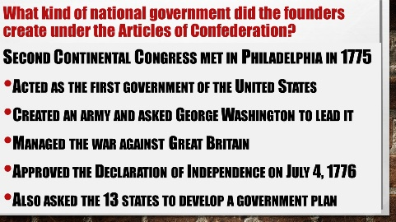 | Which do you think was more important to the Second Continental Congress, setting up a national government or fighting the war against Great Britain?
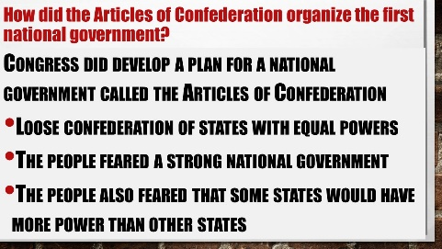 | Why do you think the people feared a strong national government?
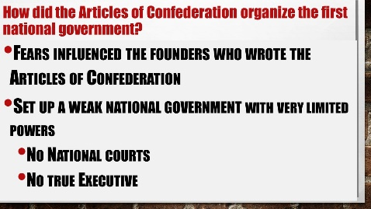 | What does it say about the Articles of Confederation that it did not have a true executive?
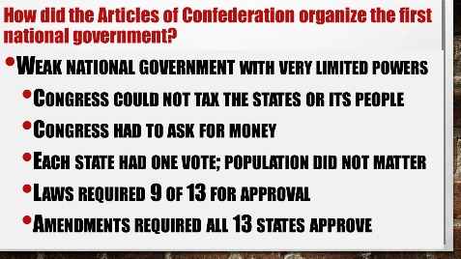 | Why do you think that the Articles required ALL thirteen states approve any amendment?

Step 4 – Interactive Lecture Thinking Question. Answer the question below based on the previous lecture.
Was the people’s fear of a strong national government and lack of a true executive connected? Explain your thoughts either way.

Step 5 – Reading: “Rogue Island”—Rhode Island: The Last State to Ratify the Constitution
Read the short history of Rhode Island’s journey to ratify the Constitution. Complete the comprehension questions at the bottom of the page when you are finished.

Step 6 – Interactive Lecture. Answer the questions during the class discussion.
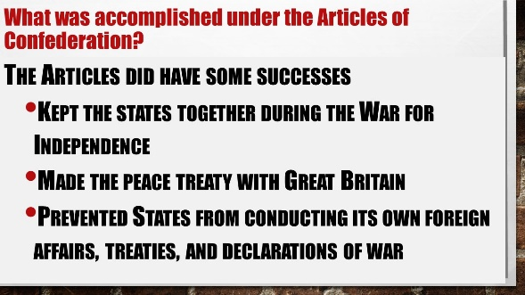 | Why do you think the national government needs to make a peace treaty with another country?
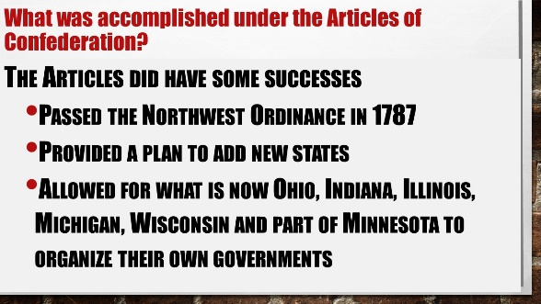 | Why you think it was important to add new states rather than for the original 13 states to make colonies on the lands to the west?
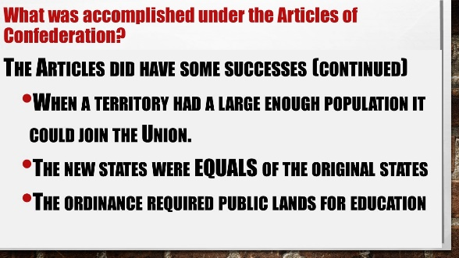 | Why do you think that the Northwest Territories provided for public education when the rest of the Union did not also fund public education?
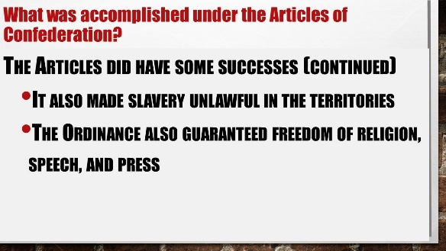 | Why you think that the Confederation Congress did not allow slavery in the Territories, but did not ban slavery anywhere else in the Union?
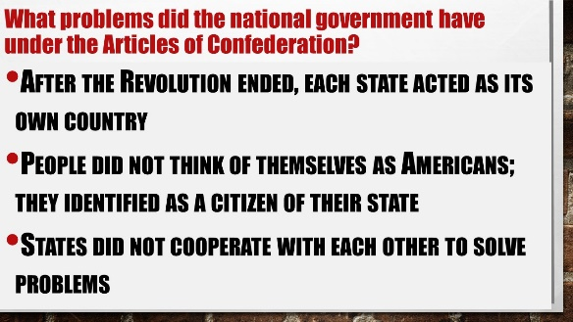 | Why you think that the Confederation Congress did not allow slavery in the Territories, but did not ban slavery anywhere else in the Union?

Step 7 – Interactive Lecture Summary. Look over your Step 6 lecture slides. What are the 3 most important accomplishments of the Articles:
- _______________________________________________________________
- _______________________________________________________________
- _______________________________________________________________
Step 8 – Interactive Lecture. Answer the questions during the class discussion.
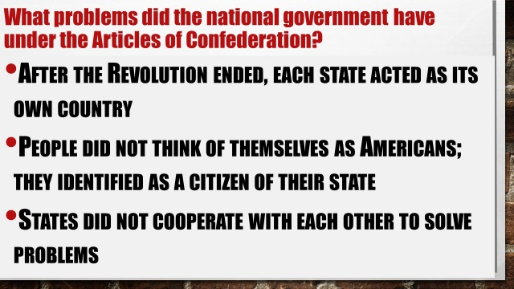 | Why do you think that people after winning the Revolutionary War did not identify themselves as Americans?
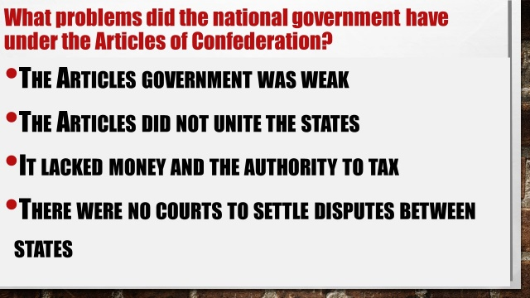 | Do you think the national government was weak under the Articles? Why or why not?
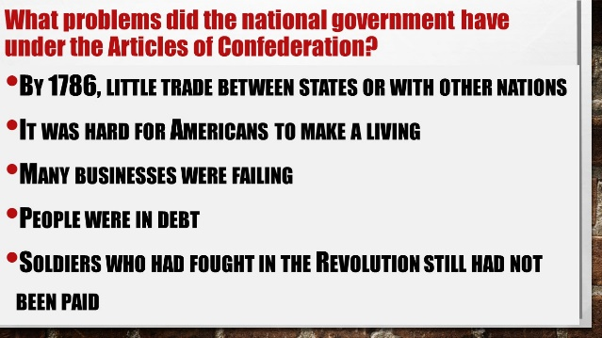 | Which of these problems do you think posed the greatest threat to the Union?

Step 9 – Thinking Question. Why do you think the Articles Congress just didn’t amend the Articles constitution to fix the problems? *Think

Step 10 – Reading: “Shays’ Rebellion: The Catalyst for a New Constitution”
Read and complete the bottom of the reading.

Step 11 – Thinking Question - What parts of our government today would stop a modern-day Shays’ Rebellion?

