Class Guide  Lesson 3 – What is a republican government? | Name: ______________________________________  Do you think 16 year citizens should be allowed in local elections? Explain.  ____________________________________________  ____________________________________________

Step 1 – Bell Work: Answer the question above and be prepared to vote with your feet and your words.
Step 2 – Vocabulary Work. Complete the vocabulary work necessary to understand this lesson. The vocabulary should be completed first. Terms to know:
Assembly | Civic Virtue | Common Good | Direct Democracy
Interests | Represent | Representative Democracy | Representatives
Republican Government | Roman Republic | Senate

Step 3 – Where did the founders get their ideas about government? Read the handout titled “Greek and Roman Influences on the US Government.” When you finish, complete the graphic organizer that breaks down the influences of Greece and Rome.

Step 4 – I Direct and Representative Democracy Interactive Lecture and Bumper Sticker Assignment.
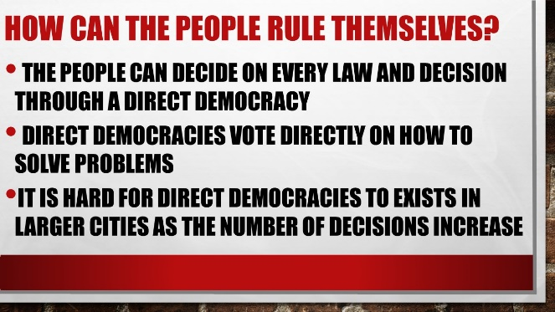 | Do you think that with the modern technologies of the internet, smart phones, and instant access that our country could be a direct democracy at the local and state level?  What would be the advantages and disadvantages?
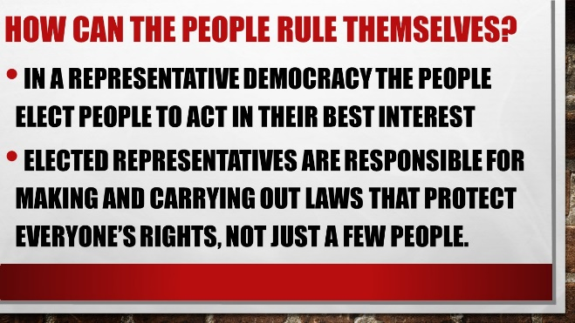 | How to the people hold their representatives accountable when they do not work in the best interest of the people?
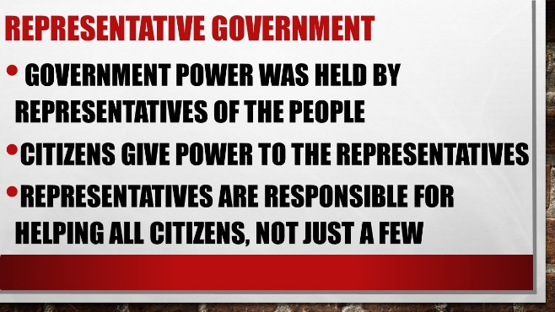 | How do the people hold their representatives accountable when they do not work in the best interest of the people?
Bumper Sticker Assignment – Direct and Representative Democracy. Look at the instructions on the Bumper Sticker Assignment.
Create three bumper stickers each for direct and representative democracies. You point out a positive or negative. Make sure the bumper stickers are:
- Related to the word
- Colorful
- Thoughtful
- Clever

Step 5 – Interactive Lecture
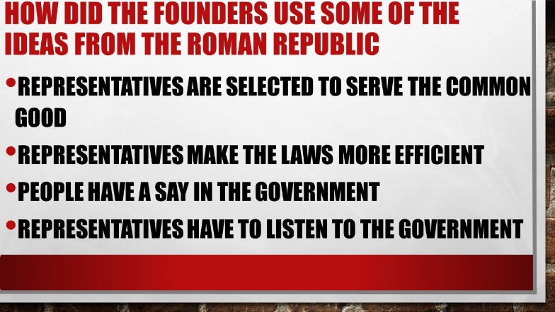 | Why do you think that representative democracies are capable of making laws faster than a direct democracy?
 | Why do you think there was a property requirement for white men to vote at the beginning of our history?
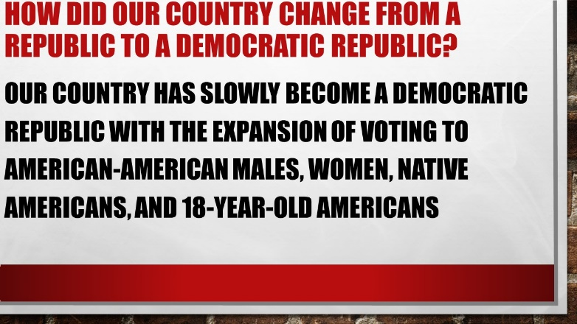 | Why do you think it took so long for women to gain the right to vote? Women received the right to vote in 1920.
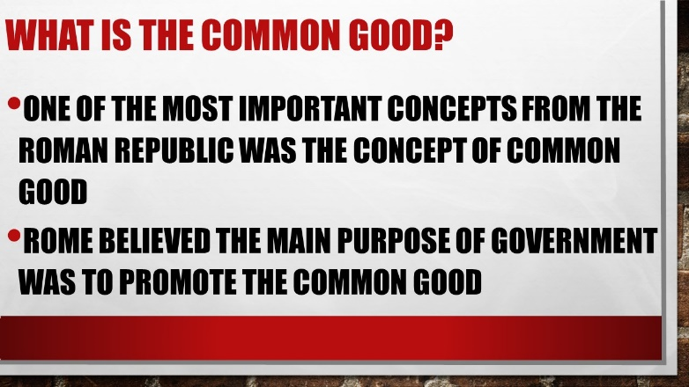 | How do people who don’t directly benefit from a common good still gain indirectly. For example, consider public education. How do people without children in school still gain indirectly from funding public schools?

Step 6 – Think, Pair, Share. Consider the two following questions
“What might be a situation in your school in which you should do something for yourself and not try to help others?”
Your thoughts | You and your partner’s thoughts

“What might be a situation in your school in which you should try to do what is best for everyone?”
Your thoughts | You and your partner’s thoughts

What did you discover from the whole class discussion?

Step 7 – Cincinnatus, Citizen of Rome and Civic Virtue. A short reading and Bio-Poem. Cincinnatus is a common example of the idea of civic virtue. Read about Cincinnatus and then create a Bio-Poem that reflects your learning of why Cincinnatus is the model of civic virtue.

Cincinnatus Comprehensive Questions. Please answer in complete sentences.
- In the story, what was the common good for the citizens of Rome?

- Why is it important that citizens in a republican government have civic virtue?

- Describe someone you know who has civic virtue. What did the person do to cause you to think they had civic virtue?

