Class Guide  Lesson 2 – Why did the Founders believe that people needed a government | Name: ________________________________  Who is the governor of Indiana?

Step 1 – Bell Work – Critical Thinking Exercise. This exercise can be found in the Upper Elementary Textbook on Page 12. Before you learn about the Founders’ beliefs about rights, let’s examine your own ideas about rights. Then you can compare your ideas with theirs. You will probably find that you and the Founders have many of the same ideas. Work with a partner or in a group of three to five students. Together answer the questions that follow. Be prepared to share your ideas with the class.
Do you think you should have the right to believe in any religion you wish? Do you think you should have the right to speak freely?
- List the rights you think you should have. Why do you think it is important to have these rights?

- Which rights seem most important? Arrange the rights you listed in order with the most important right first. Why do you think these rights are the most important? What responsibilities come with each of these rights?

- Do you think people everywhere should have these rights? Why or why not?

Step 2 – Vocabulary Work. Complete the vocabulary work necessary to understand this lesson. The vocabulary should be completed first. Terms to know:
Consent | Consent of the Governed | Liberty | Life
Natural Rights | Property | Social Contract | State of Nature

Step 3 – Interactive Lecture. Answer the questions during the class discussion.
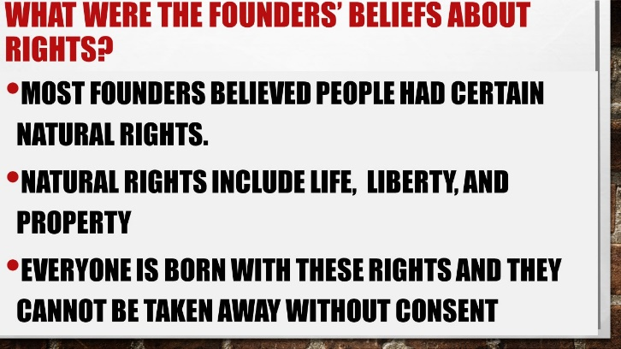 | The idea of natural rights was embraced in the colonies, but was an unpopular idea in the noble classes of 1700s Europe. Why do you natural rights was unpopular in Europe during the 1770s?
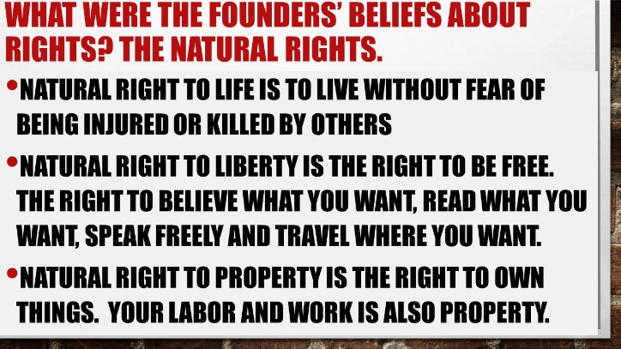 | Which of these three natural rights matters the most to you? Explain.
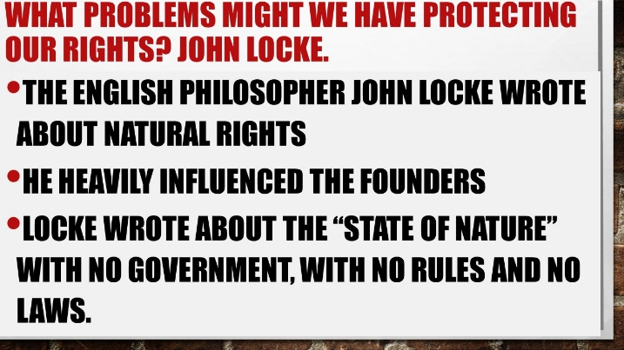 | What do you think it might be like in a “state of nature”?

Step 4 - Critical Thinking Exercise. This assignment is found in the Upper Elementary textbook on Page 15. What might happen if there were no rules, laws or government?
Imagine that you live on an island far away. There are no rules, no laws and no government. There is no one to tell you what to do. Work with a partner or small group. Answer the questions below after you discuss as a group.
- Would anyone have the right to govern you? Would you have the right to govern anyone else? Why?

- Would you have any rights? What might they be? *Think

- What might people who were smarter or stronger than others try to do? Why?

- What might people who were not as smart as others or who were weaker than others try to do? Why?

- What might life be like for you, your family, and everyone else in a state of nature?

Step 5 – Interactive Lecture. Answer the questions during the class discussion.
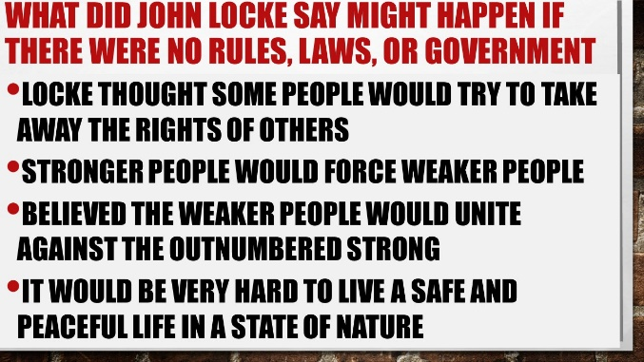 | How did your thoughts on the “state of nature” compare with John Locke’s?
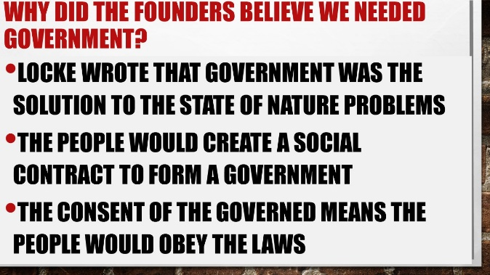 | What do you think is the most important thing the people gain from the “social contract”?
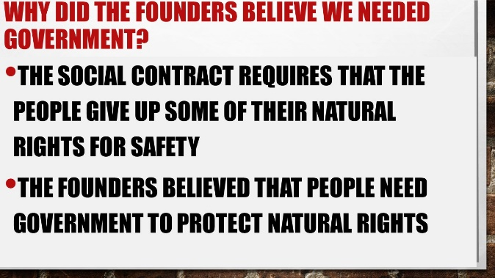 | Can you give an example of the “natural rights” that the people give up when the people establish a government through the “social contract”?

Step 6 – Analysis of the Mayflower Compact—America’s First Social Contract.
Read the background to the Mayflower Compact and the Mayflower Compact’s text.
Identify the three (3) things the signers of the mayflower compact agreed to do
Lastly, explain how the mayflower compact is an example of a social contract

