Class Guide  Lesson 1 – What were people like in the British colonies in America during the 1770s? | Name: ________________________________  Can you name one of the Founders of the United States?

Step 1 – Bell Work: Imagine that the United States was still a colony of Great Britain. How do you think your daily life would be different?

Step 2 – Vocabulary Work. Complete the vocabulary work necessary to understand this lesson. The vocabulary should be completed first. Terms to know:
Colony | Diverse | Founders | Indentured Servant
Plantation | Self-Sufficient | Slave | Mercantilism

Step 3 – Read the article “Colonial Mercantilism”. Complete the impact chart at the bottom of the reading to understand how Great Britain benefited at the expense of the thirteen colonies.
Step 4 – Interactive Lecture – “What was it like to live in the colonies in the 1770s”.
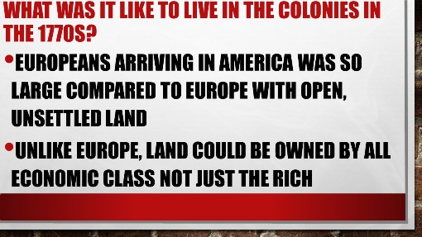 | What impact do you think it had in Europe for only the rich could own land?

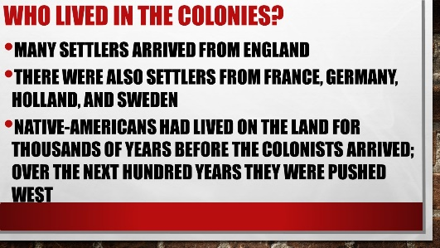 | Why do you think Native-American pushed West instead of fighting for their ancestral land?
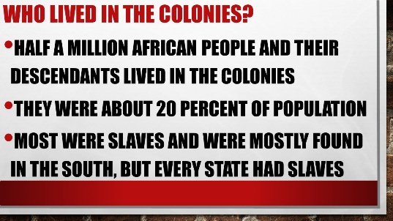 | Why do you think the Southern economies used slave labor?
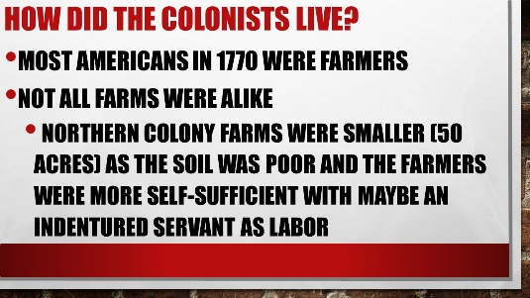 | Why do you think there were less slaves in the Northern colonies?
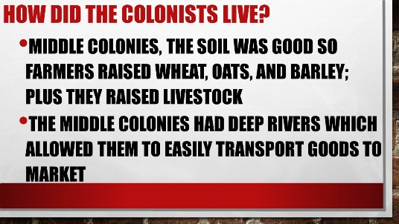 | Why were deep rivers that flowed west to east such an advantage in the Middle Colonies?
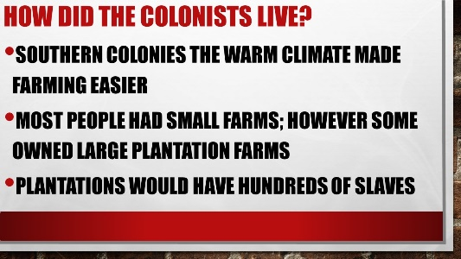 | Why were deep rivers that flowed west to east such an advantage in the Middle Colonies?

Step 5 – Read the article “What Opportunities Did This Colonial Farmer Enjoy? One farmer who wrote about his life in the colonies was Philip Taylor. Read what he wrote. Work with a partner to answer the questions that follow. Be prepared to share your ideas with the class.

Step 6 – Interactive Lecture – Part II – “What was it like to live in the colonies in the 1770s”.
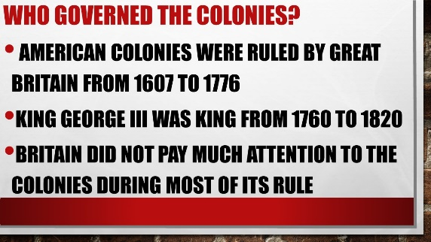 | Why do you think that Great Britain ignored the colonies through most of its rule?
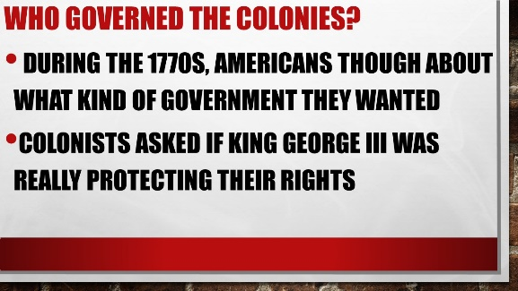 | If you lived in the colonies in the 1770s, would you think the times were exciting to something to fear?
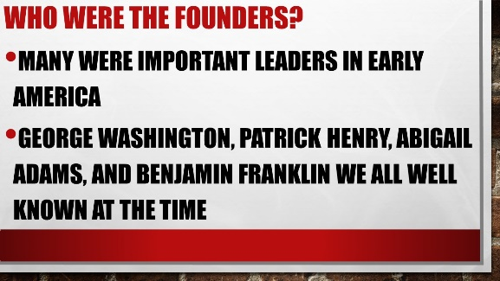 | What would the founders by considered by the eyes of the British government in the 1770s?
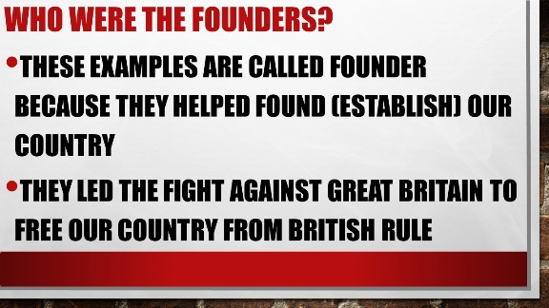 | What do you think the founders risked by supporting independence from Great Britain?

Step 7 – Read the mini-biography on Abigail Adams. Once you finish reading complete an historical marker on her life.

